Algoritmi in zanke Učni list za utrjevanje znanja
1. Zapiši postopek za peko palačink v štirih korakih.
_________________________________________________________________________________________________________________________________________________________________________________________________________________________________________________________________________________________________________________________________________________________________________________________________________________________________________________________________________________________________________________________
2. Ali je postopek na desni strani zapisan pravilno (ali da bo Elsa prišla do računalnika)? Če ni, postopek spremeni oziroma dopolni.
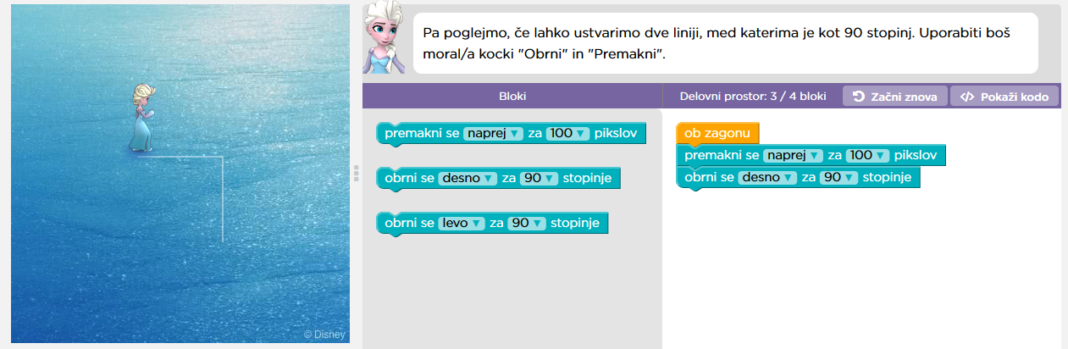

___________________________
___________________________

3. Zapiši postopek, ki bo Elsi pomagal narisati kvadrat. Pri tem si pomagaj z bloki zapisani na desni stran.
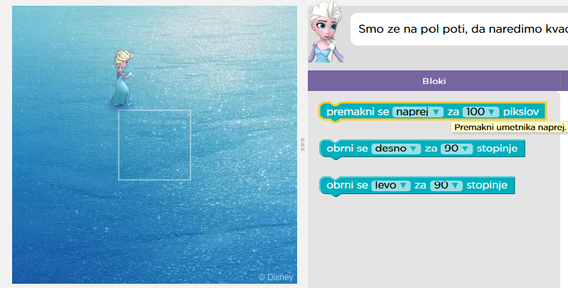
____________________________________________________________________________________________________________________________________________________________________________________________________________________________________________________________________________________________________________________________________________________________________________________________________________________
4. Sedaj pa zapiši isti postopek kot si ga zapisal/a pri prejšnji nalogi le krajše. Pri tem si pomagaj z blokom spodaj.


